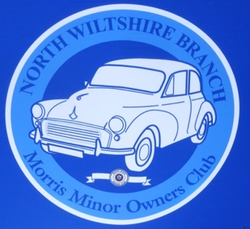 **North Wiltshire Branch MMOC**

[www.northwiltsmmoc.co.uk](http://www.northwiltsmmoc.co.uk)

**Subscription Form 2022**

Membership of the North Wilts MMOC Is by annual subscription of £10 per person.

(£20 for 2 people at the same address)

Non-members attending meetings will be asked to pay a £2 donation to the club.

Name(s):

Address:

Telephones - Mobile:       Landline:

Email address:

MMOC Membership No.

Car registration no.       Model:       Year:

Colour:       Name of car:

**North Wiltshire MMOC Committee will not share any personal details to a third party**

**without permission.**

**I agree for my email address to be used to receive information with regard to branch**

**activities.**

**Signed: Name:**

**Payment of subscription.**

Please make payment by electronic transfer to:

**North Wilts MMOC. Sort code: 30-13-35 Account number: 02710987**

Reference: **Subs/your second name**. (e.g. Subs/Holmes)

Complete this subscription form and email it to: [pamlynnholmes@icloud.com](mailto:pamlynnholmes@icloud.com)

**I have paid by electronic transfer to North Wilts MMOC account on** **(Date)**

If you are unable to pay on-line then post a cheque with a completed subscription form to:

Pam Holmes, Orchard End, The Street, Castle Eaton, Swindon. SN6 6JZ

If you have any questions then our treasurer Pam Holmes can be contacted on 01285 810524.